**DSA LAB - 2**

**Name:** Etcherla Sai Manoj **Mis. No:** 112015044 **Branch:** CSE

**Question 1:**

**Code:**

#include<iostream>

using namespace std;

int main(){

float amount, income_tax, state_tax, securtiy_tax, medicare_tax, pension_plan;

cout << "\nEnter Gross payment amount : ";

cin >> amount;

//displays individual tax deductions

cout << "\n--------------------------------------------------------------------------\n";

cout << "Taxes\t\tDeduction amount\n" << endl;

cout << "Income tax\t\t" << 0.10*amount << endl;

cout << "State tax\t\t" << 0.03*amount << endl;

cout << "Social securtiy tax\t" << 0.02*amount << endl;

cout << "Medicare tax\t\t" << 0.0278*amount << endl;

cout << "Pension plan\t\t" << 0.06*amount << endl;

cout << "\n\nTotal amount deduced as tax : " << 0.10*amount+0.03*amount+0.02*amount+0.0278*amount+0.06*amount << endl;

//calculate total payment amount after tax deductions;

cout << "The total payment to the worker after following tax deductions : ";

cout << amount - (0.10*amount) - (0.03*amount) - (0.02*amount) - (0.0278*amount) - (0.06*amount) << endl;

cout << "--------------------------------------------------------------------------\n\n";

return 0;

}

**Code:**

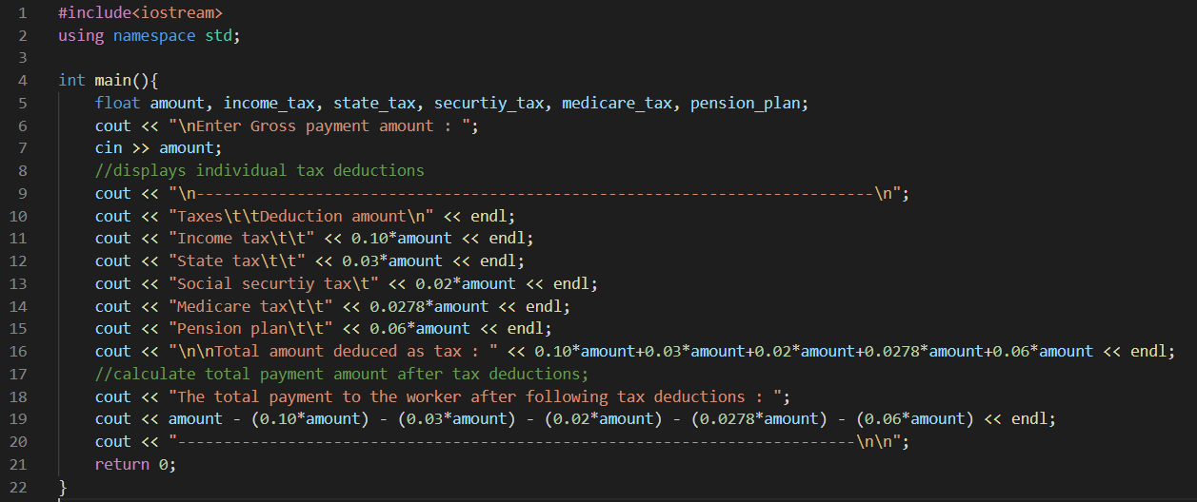

**Input & Output:**

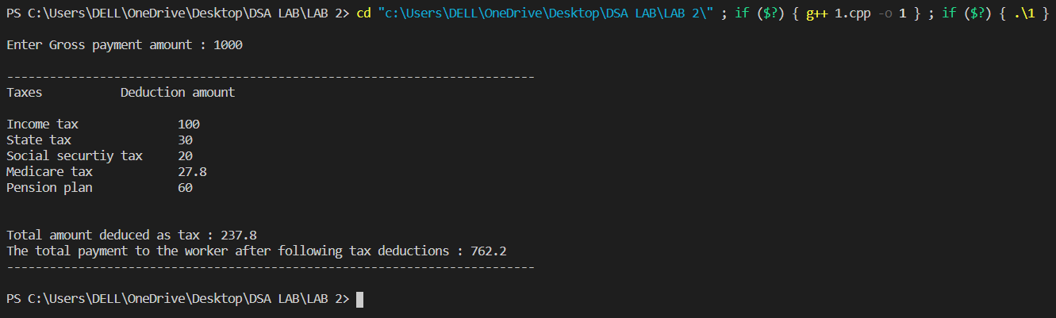

**Question 2:**

**Code:**

#include<iostream>

using namespace std;

void cprint(int c){

//prints C's in pattern

for(int a = 0; a < c; a++)cout << "C";

}

void plusprint(int plus){

//prints +'s in pattern

for(int a = 0; a < plus; a++)cout << "+";

}

int main(){

int c, plus;

cout << "\n";

for(int i = 1; i <= 6; i++){

if(i==1 || i==6) c = 9, plus = 2;

if(i==2 || i==5) c = 2, plus = 2;

if(i==3 || i==4) c = 2, plus = 14;

//C's printing function

cprint(c);

//prints identation or spacing

if(i==2||i==5) cout << "\t ";

else if(i==1 || i==6) cout << " ";

else cout << "\t";

//+'s printing function

plusprint(plus);

//prints identation or spacing

if(i==3 || i==4) cout << "\t";

else cout << "\t ";

//+'s printitng function for second time

plusprint(plus);

cout << endl;

}

cout << "\n";

return 0;

}

**Code:**

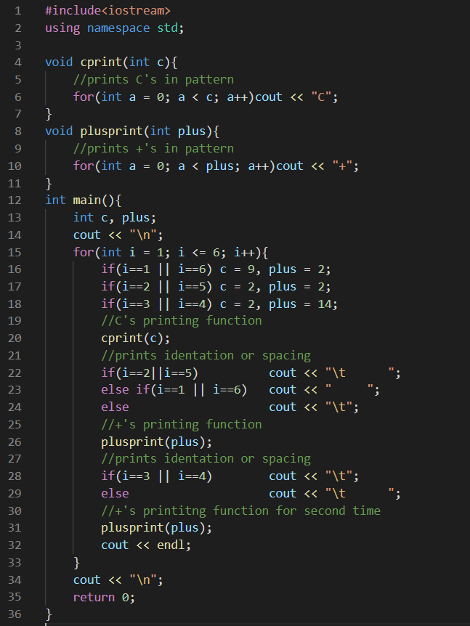

**Input & Output:**

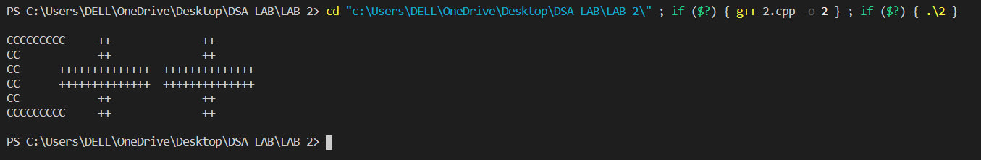

**Question 3:**

**Code:**

#include<iostream>

using namespace std;

int main(){

float fahrenheit, celsius;

cout << "\nEnter temperature in Fahrenheit : ";

//Read fahrehheit temperature from user

cin >> fahrenheit;

//Converts fahrenheit into celsius

celsius = (5.0 / 9.0) * (fahrenheit-32);

//Displays temperature in celsius

cout << "Temperature in Celsius : " << celsius << "\n\n";

return 0;

}

**Code:**

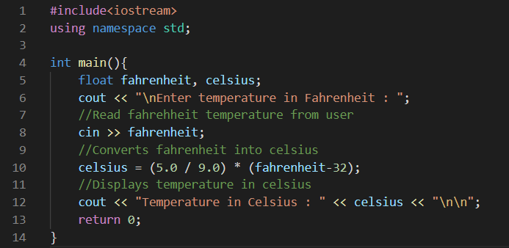

**Input & Output:**

